**WEB SCRAPPER**

This project automates the extraction of job listings from LinkedIn and Naukri using Selenium. The scraped data (title, company, location, link, etc.) is saved to a CSV file. The code is modular, with separate components for scraping, driver configuration, and file handling.

**Project Structure:** 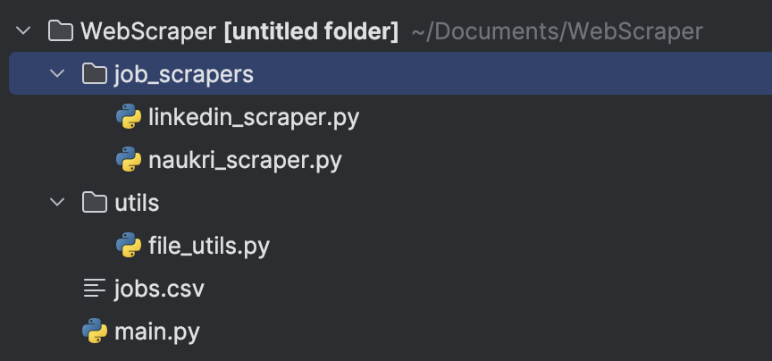

**Required dependencies:**

|  |  |
| --- | --- |
| **Package** | **Purpose** |
| Selenium | Browser automation |
| csv | CSV file operations |
| urllib.parse | URL encoding |
| time | Delay management |

**Installation:**

Using pip install

Eg. pip install selenium

**Key components:**

**1. Driver Configuration (configure\_driver())**

* Uses headless Chrome with anti-bot detection flags.
* Chromedriver Path: Update in all configure\_driver() functions if needed.
* Example configuration:

options.add\_argument("--disable-blink-features=AutomationControlled")

service = Service("/path\_to\_chromedriver")

**2. LinkedIn Scraper (linkedin\_scraper.py)**

* Authentication: Uses hardcoded credentials (security risk in production).
* URL Format: https://www.linkedin.com/jobs/search/?keywords={job\_title}&location={location}
* Data Collected:

{

"Title": " ",

"Company": " ",

"Location": " ",

"Type": " ",

"Link": "https://linkedin.com/jobs/123",

"Platform": "LinkedIn"

}

**3. Naukri Scraper (naukri\_scraper.py)**

* URL Format: https://www.naukri.com/{job\_title}-jobs-in-{location}
* Scrolls to load additional jobs.
* Same data as above is collected

**4. CSV Saving (file\_utils.py)**

* Output Path: as described by the user
* Fields: title, company, location, link, timestamp
* Appends data to existing files.

**Setup Instructions**

1. **Install Chromedriver**:
   * Download from [Chromedriver](https://chromedriver.chromium.org/" \t "_blank)
   * Update path in all configure\_driver() functions:

service = Service("/your\_chromedriver\_path")

1. **Run the Script**:

python main.py

1. **Enter job title and location when prompted.**
2. **Open the csv file at given location to find the information about the job card**

**Example usage:**

****

**